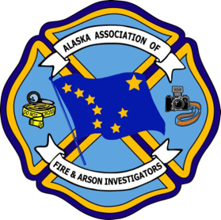
Alaska Chapter/International Association of Arson Investigators, Inc.
Application for Membership

New/Renew Alaska Chapter Only Membership - $75.00
All information given by me is warranted to be true and accurate.

Prefix: First: M.I.: Last: Suffix:
Home Address

City State/Province Zip/Postal Code Country

Home # ( ) E-mail Address:

Employer Supervisor
Title

Business Address

City State/Province Zip/Postal Code Country

Work # ( ) Fax # ( ) Cell # ( )

Occupational Affiliation (Select One)
Fire Investigator-Fire Department-Local/County Fire Investigator-Police/Peace Officer-Local/County
Fire Investigator-State/County Fire Investigator-Federal Fire Investigator-Private
Firefighter/Officer Police Officer/Detective Insurance Claims Adjuster Insurance SIU
Engineer PE, EE, Etc. Attorney-Prosecutor Attorney-Private Sector Forensic Laboratory
Forensic accountant Instructor Retired

Have you ever been convicted a crime, felony or misdemeanor? Note: A yes answer to this question may affect your acceptance as a member of the Alaska Association of Fire and Arson Investigators.
No Yes If yes, explain offense and date/location of conviction.

Charge my membership dues Amex Visa Master Card Account #
Name on card Expiration date
Billing Address
Applicant’s signature Date:

Mail to:
AAFAI, PO Box 671468, Chugiak, AK 99567 or afi@alaskafireinvestigators.org
01/2020
Online Registration: alaskafireinvestigators.org/conference

